Introduction to Programming

1. Write an algorithm in pseudo-code to get a name from the user and display a greeting to the user.

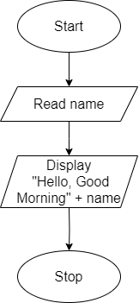

2. Write a simple algorithm in pseudo-code that takes two numbers as input and displays their sum, difference, product, and division.

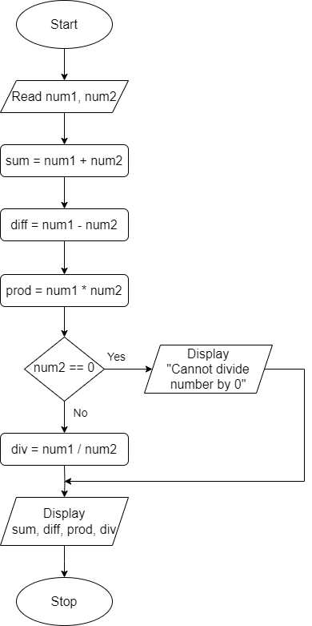

3. Write an algorithm in pseudo-code that takes two numbers as input and displays the larger of the two.

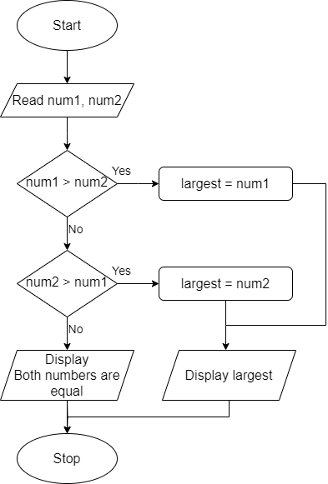

4. Write an algorithm in pseudo-code that takes a number as input and displays whether it's positive, negative, or zero.

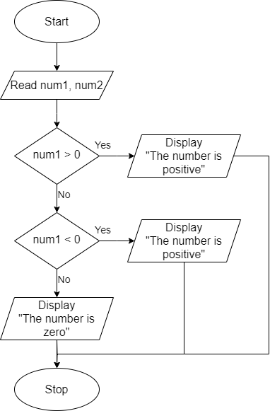

5. Write an algorithm in pseudo-code that takes three numbers as input from the user and calculates their average value.

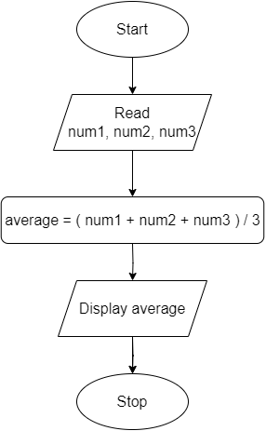

6. Write an algorithm in pseudo-code that converts temperature from Celsius to Fahrenheit.

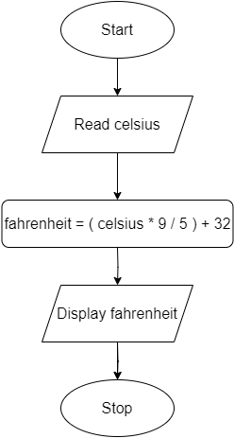

7. Write an algorithm in pseudo-code that calculates simple interest based on the principal amount, rate, and time.

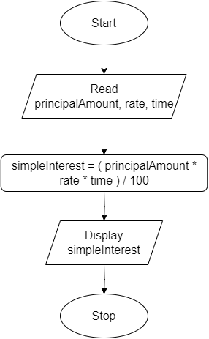

8. Write an algorithm in pseudo-code that takes a number as input and displays the sum of its square and its cube.

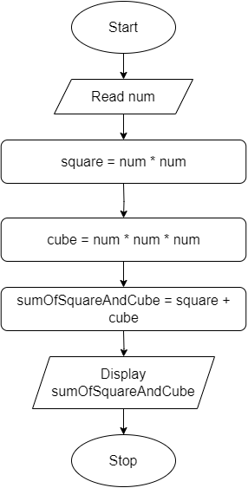

9. Write an algorithm in pseudo-code that calculates the ticket price for a movie based on the age of the customer as per the following criteria –

| **Age** | **Price** |
| --- | --- |
| Children (age <= 12) | $5 |
| Adults (age > 12 and <= 65) | $10 |
| Seniors (age > 65) | $7 |

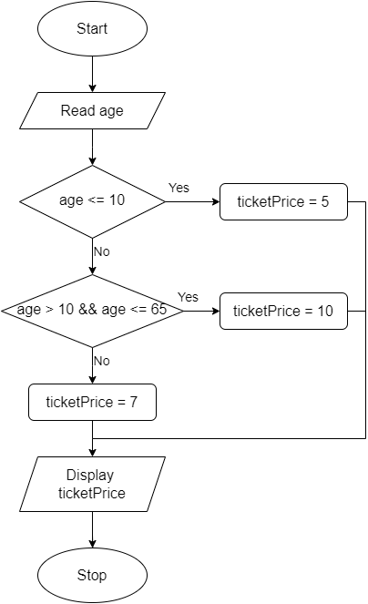

10. Write an algorithm that determines if a given year is a leap year or not. Leap years are divisible by 4, but if they are divisible by 100, they must also be divisible by 400.

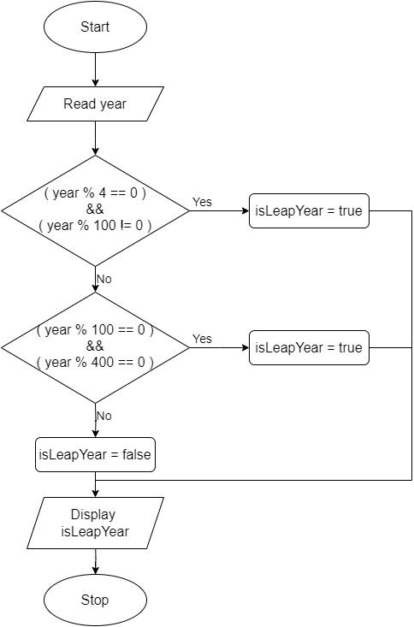

# Practice Questions DIY

1. Write an algorithm in pseudo-code to get an age of a person as an input and display whether the person is eligible to vote or not. (A person with age more than 18 is considered to be eligible to vote.)

2. Write an algorithm in pseudo-code to get an age of a person as an input and display whether the person is a child or teenager or an adult.

3. Write an algorithm in pseudo-code to get a number indicating the student’s score as an input and determine and display grade based on the following criteria –

| **Score** | **Grade** |
| --- | --- |
| 90 and above | A |
| 80-89 | B |
| 70-79 | C |
| 60-69 | D |
| Below 60 | F |

4. Write an algorithm in pseudo-code to get a character as input from the user and determine and display if its vowel or a consonant.

5. Write an algorithm in pseudo-code to convert temperature from Fahrenheit to Celsius.